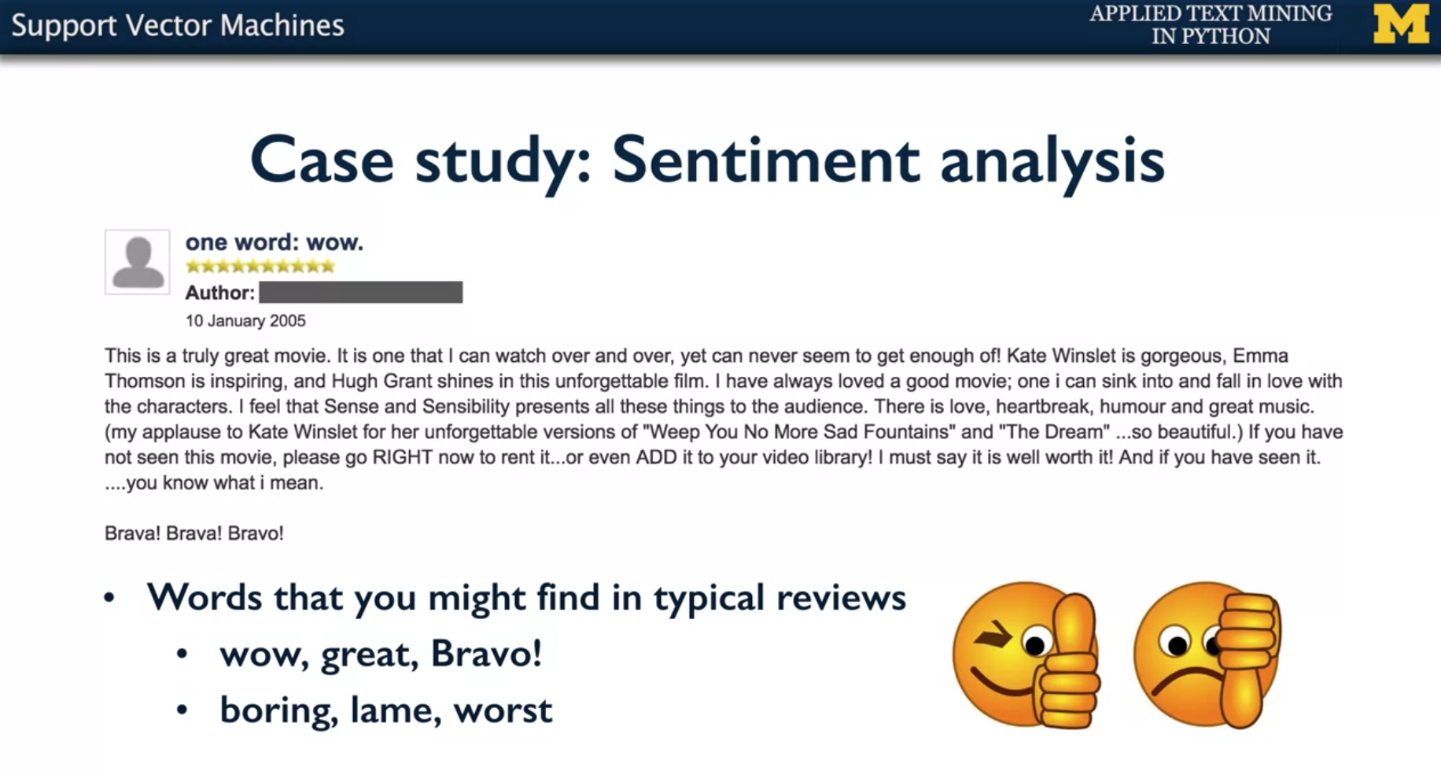

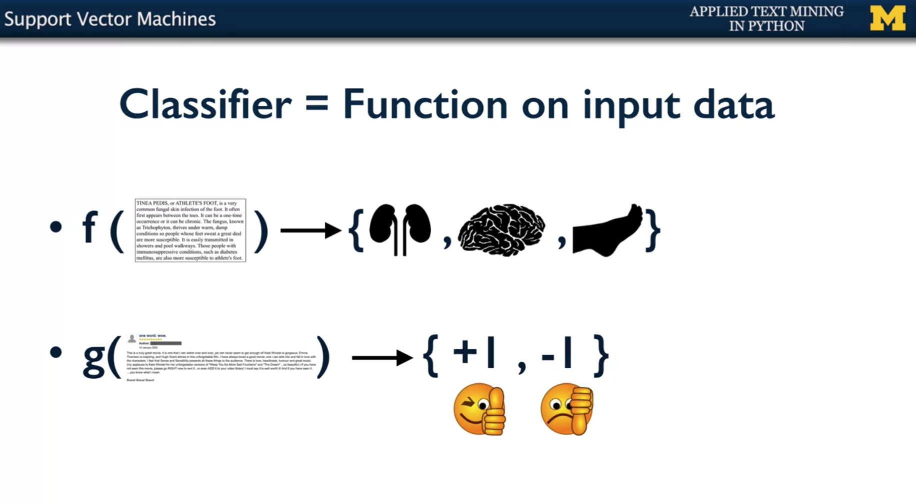

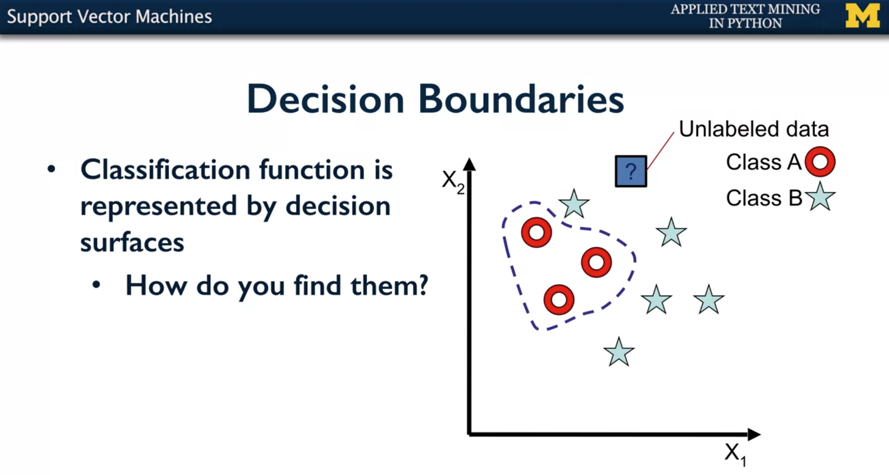

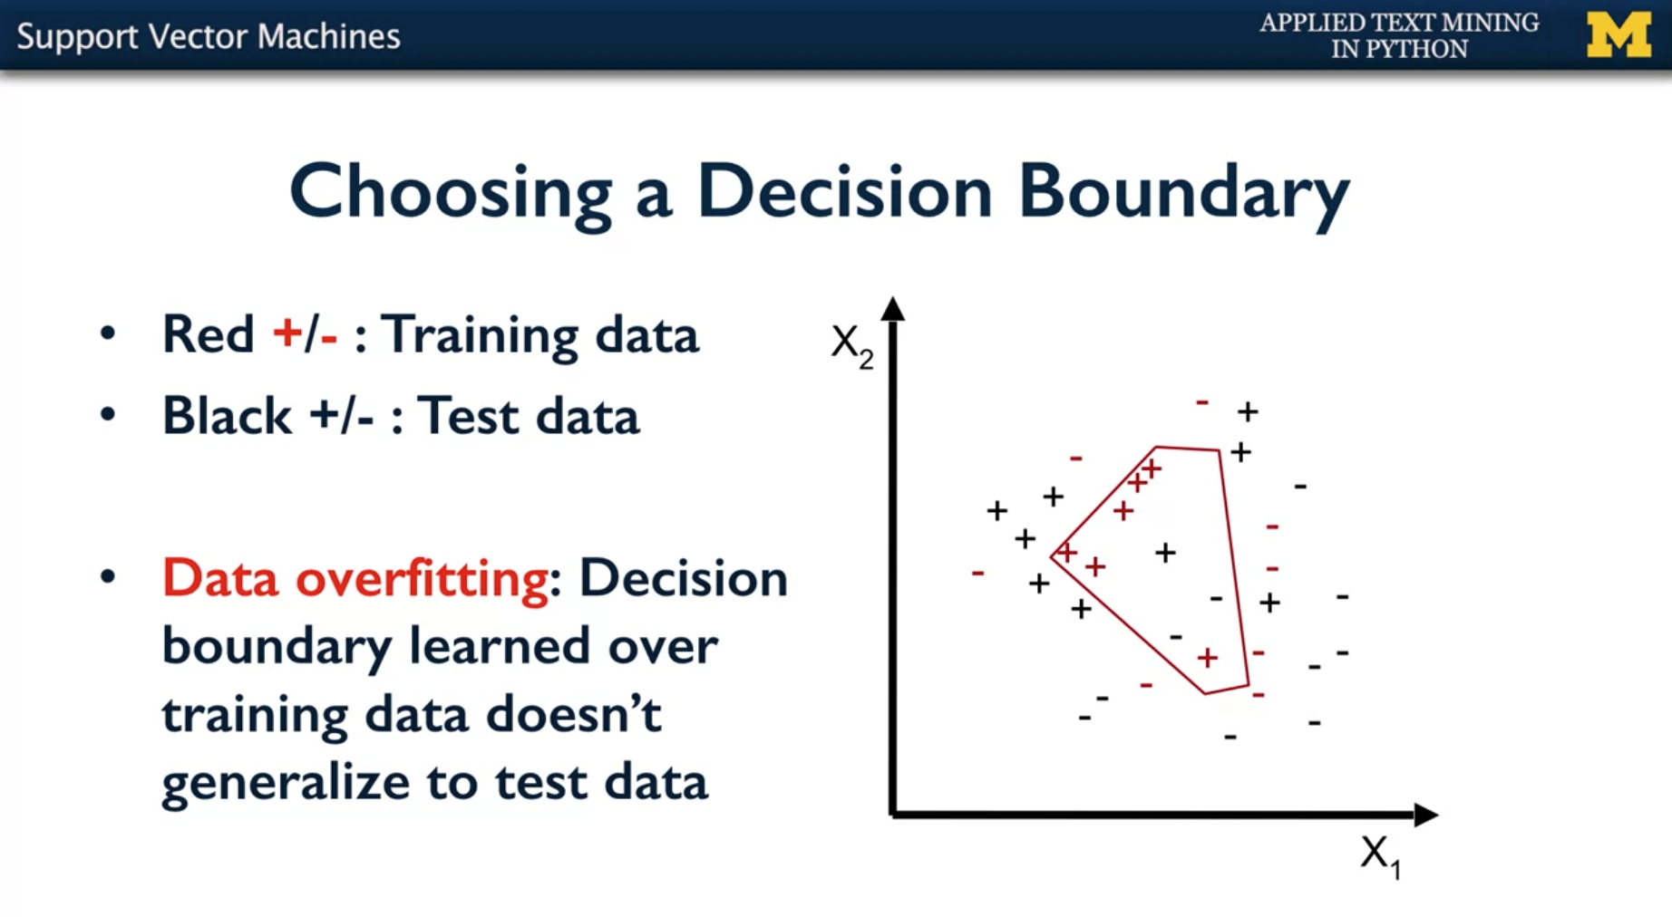

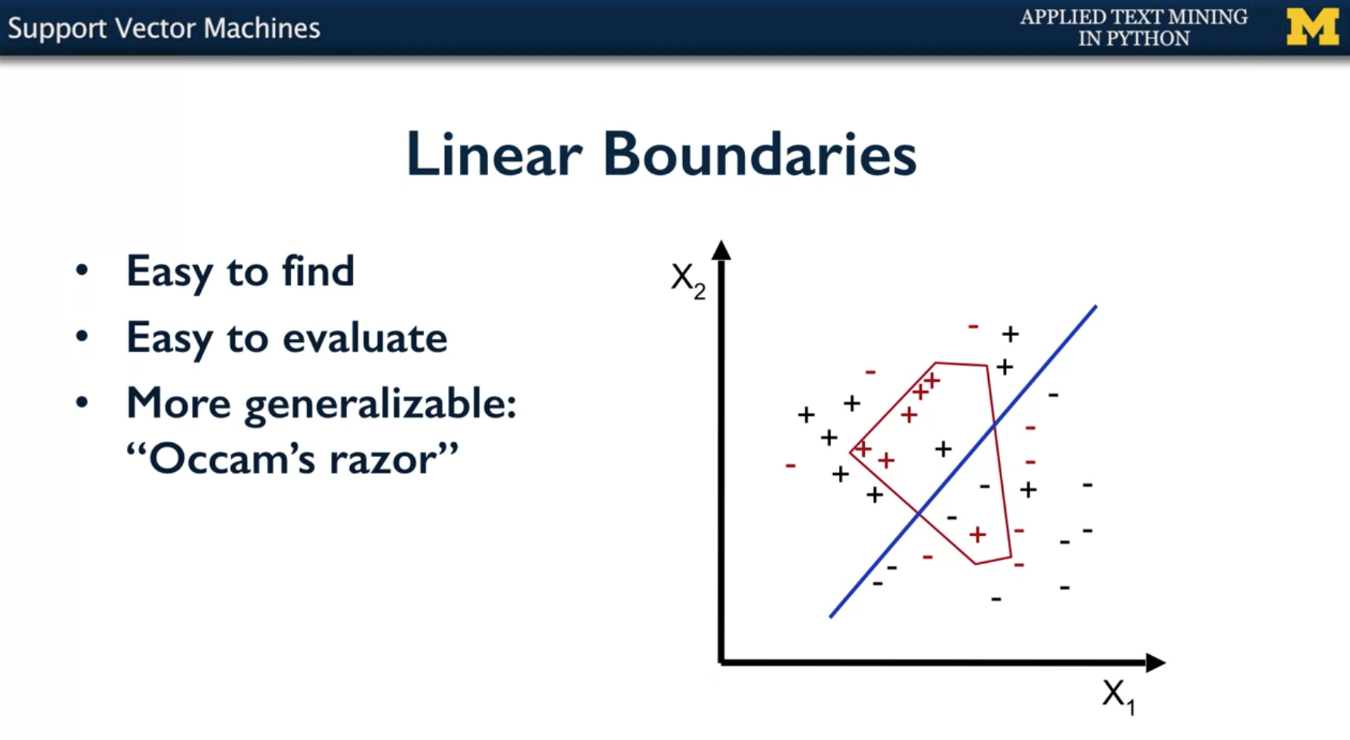

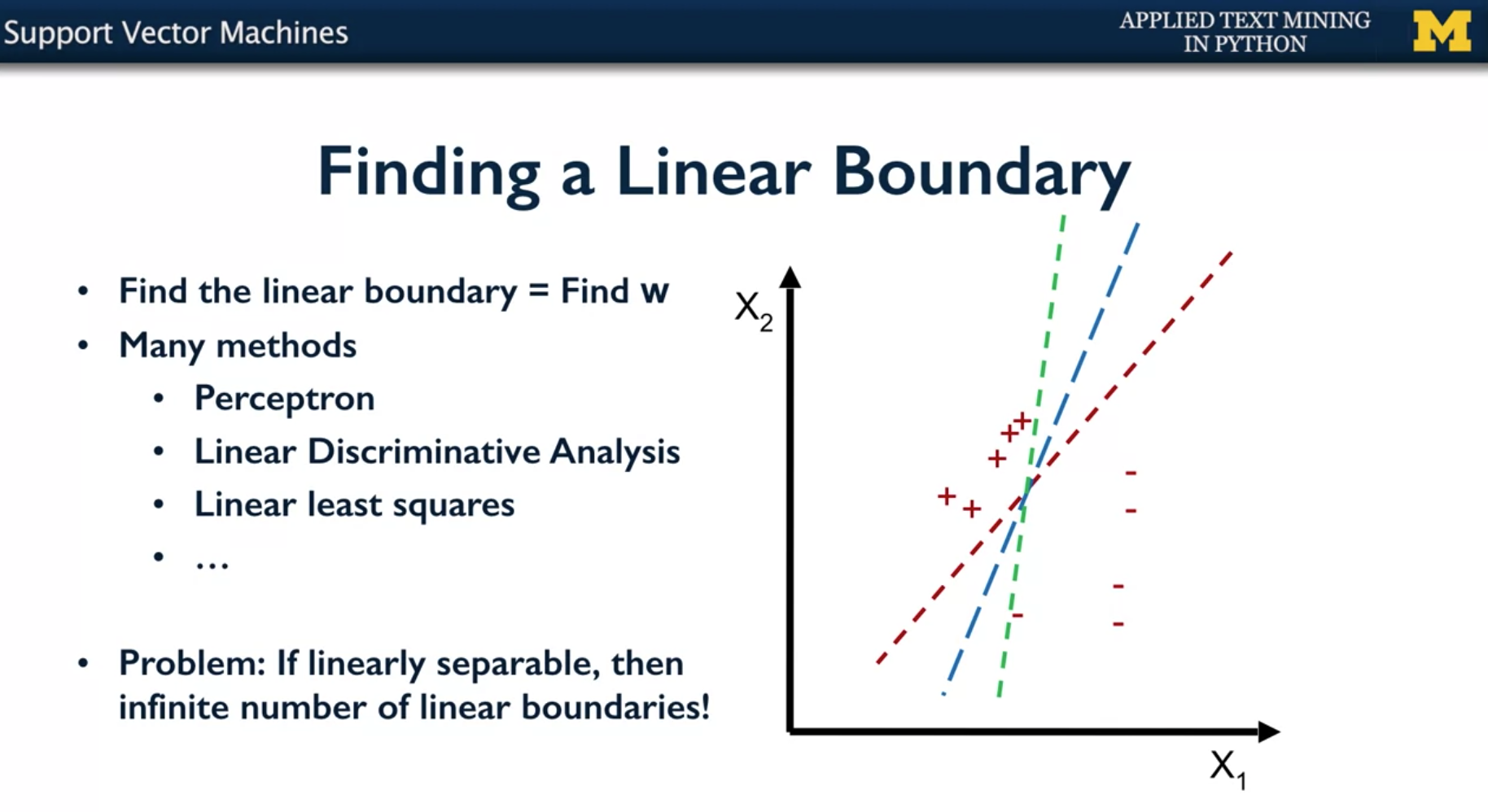

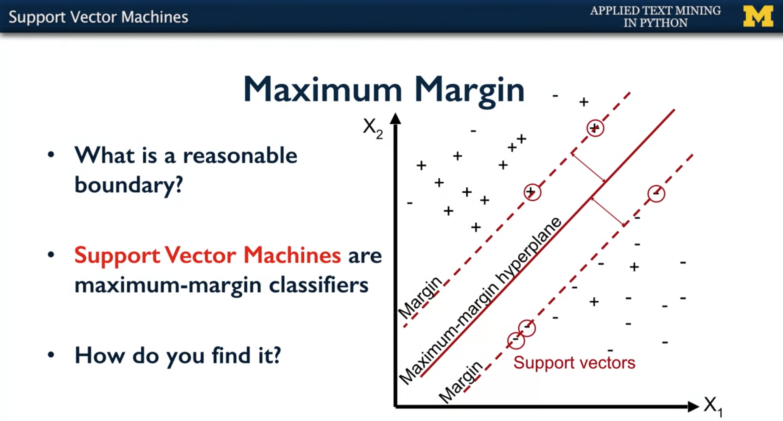

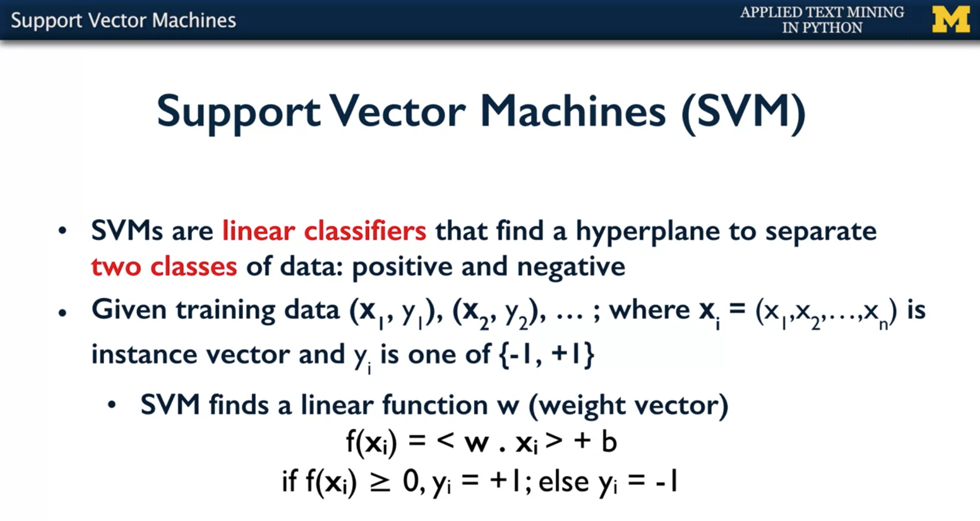

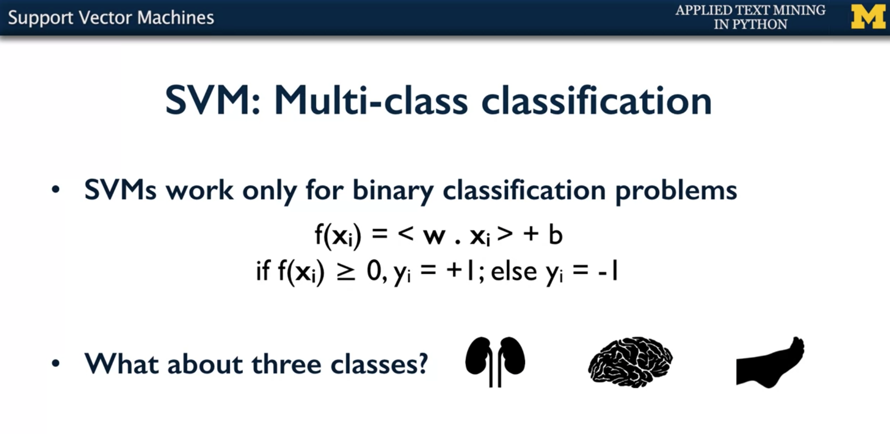

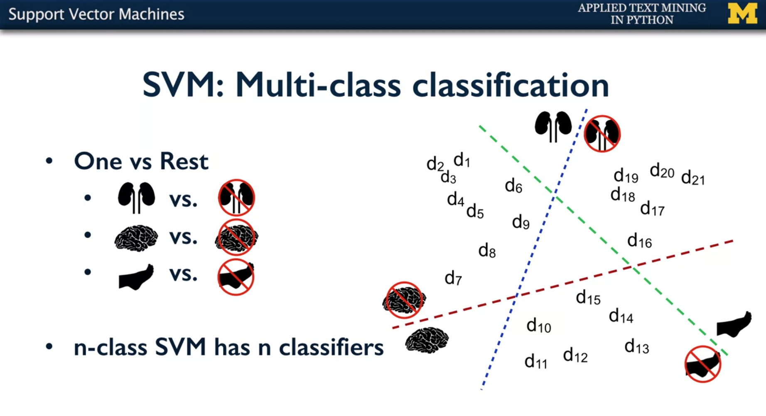

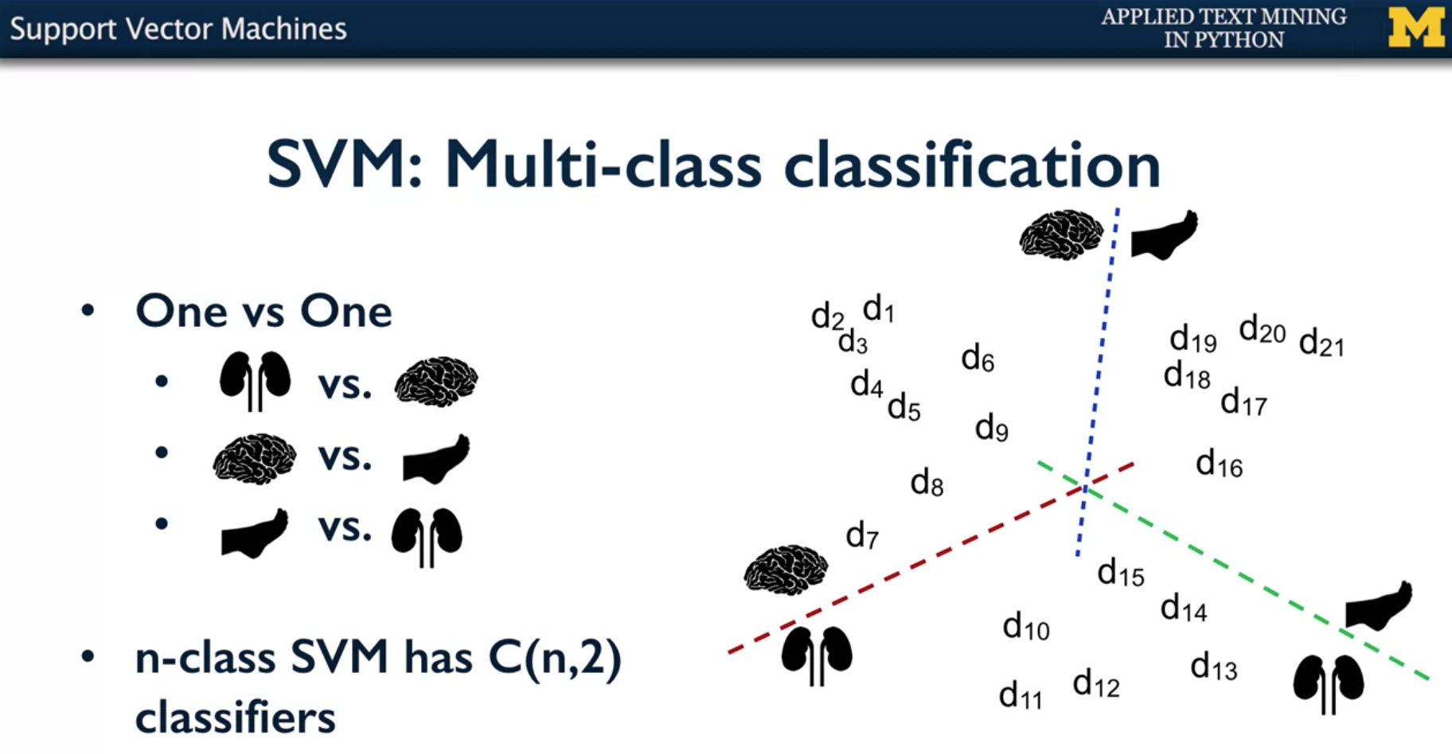

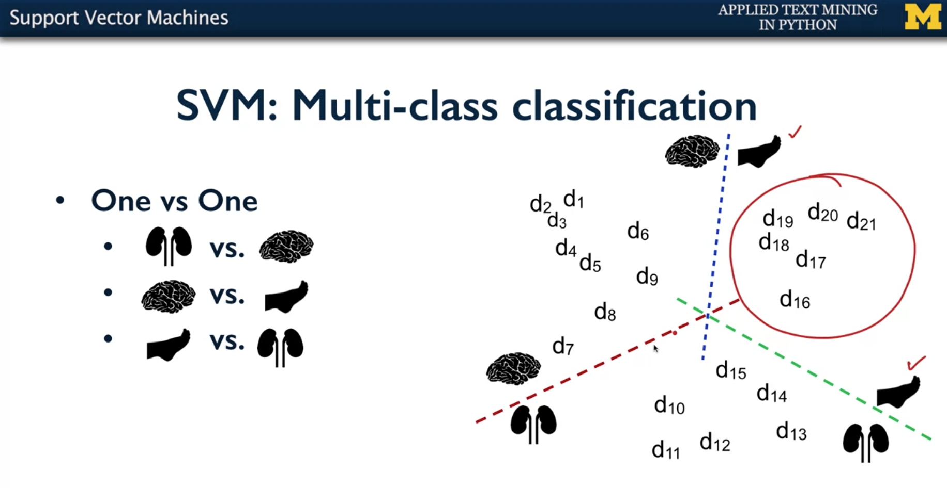

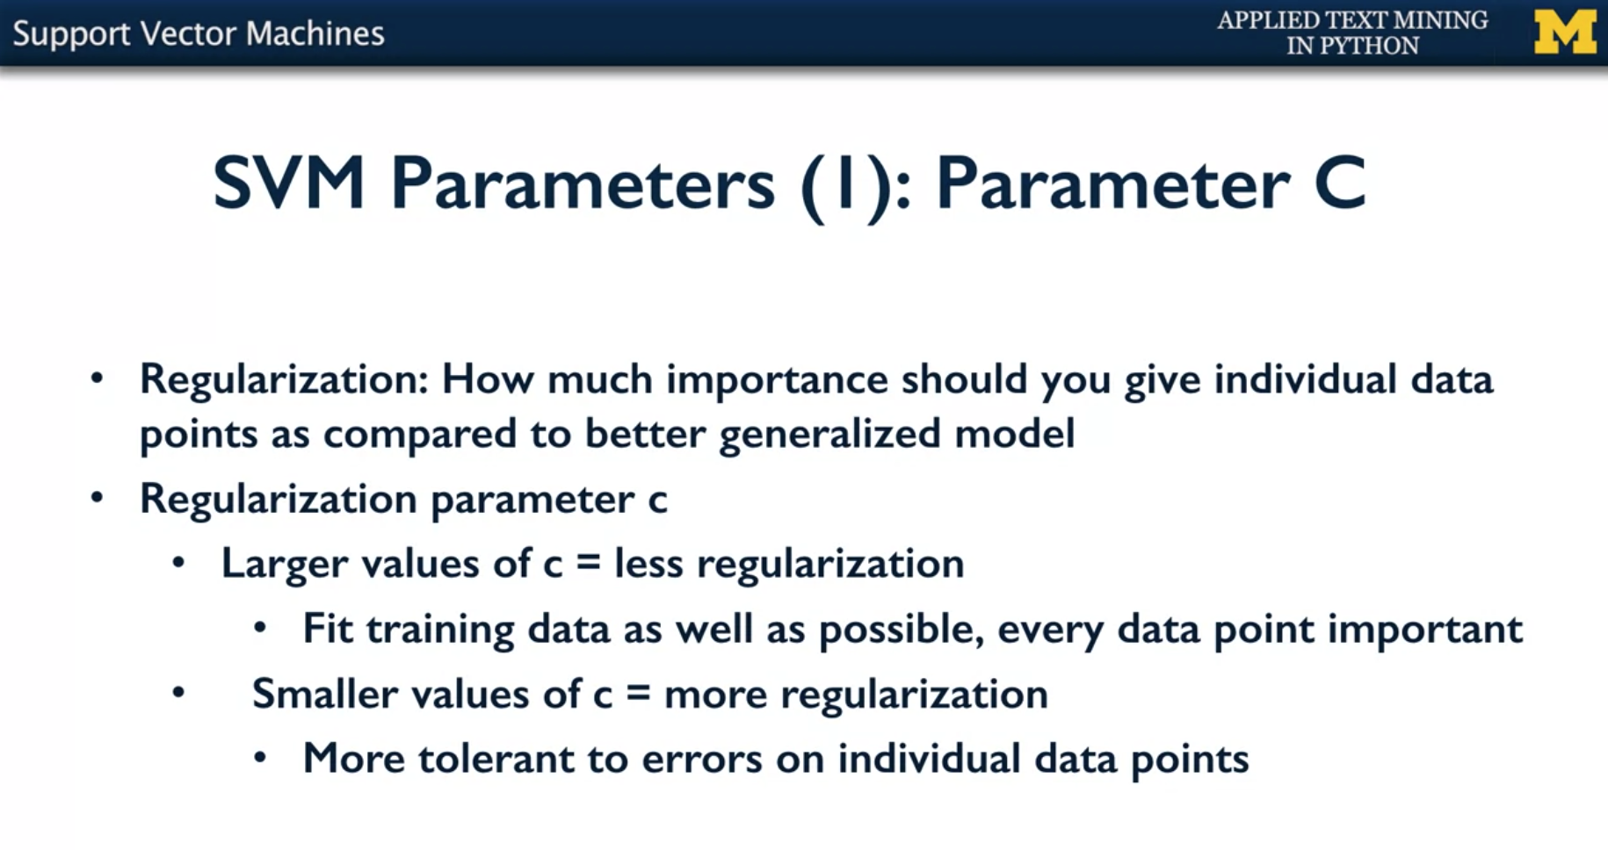

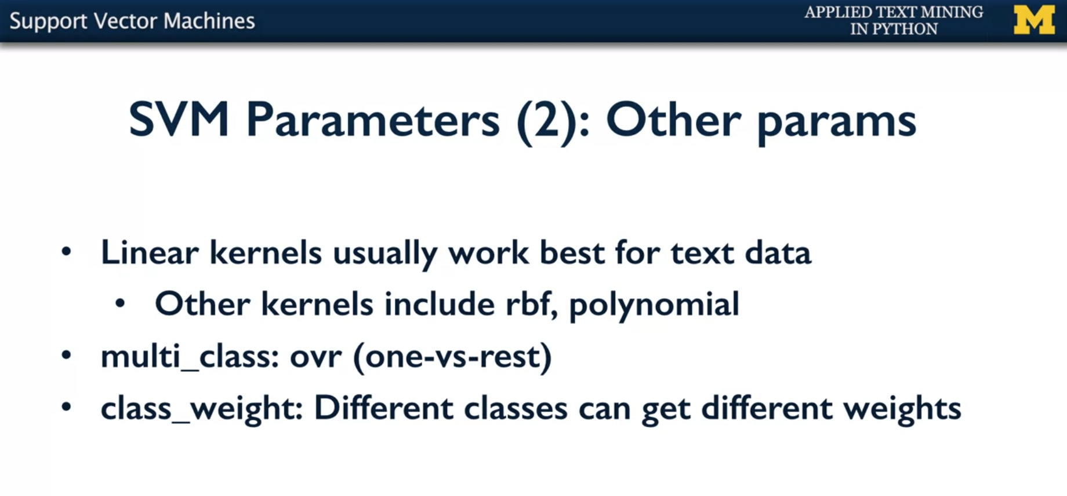

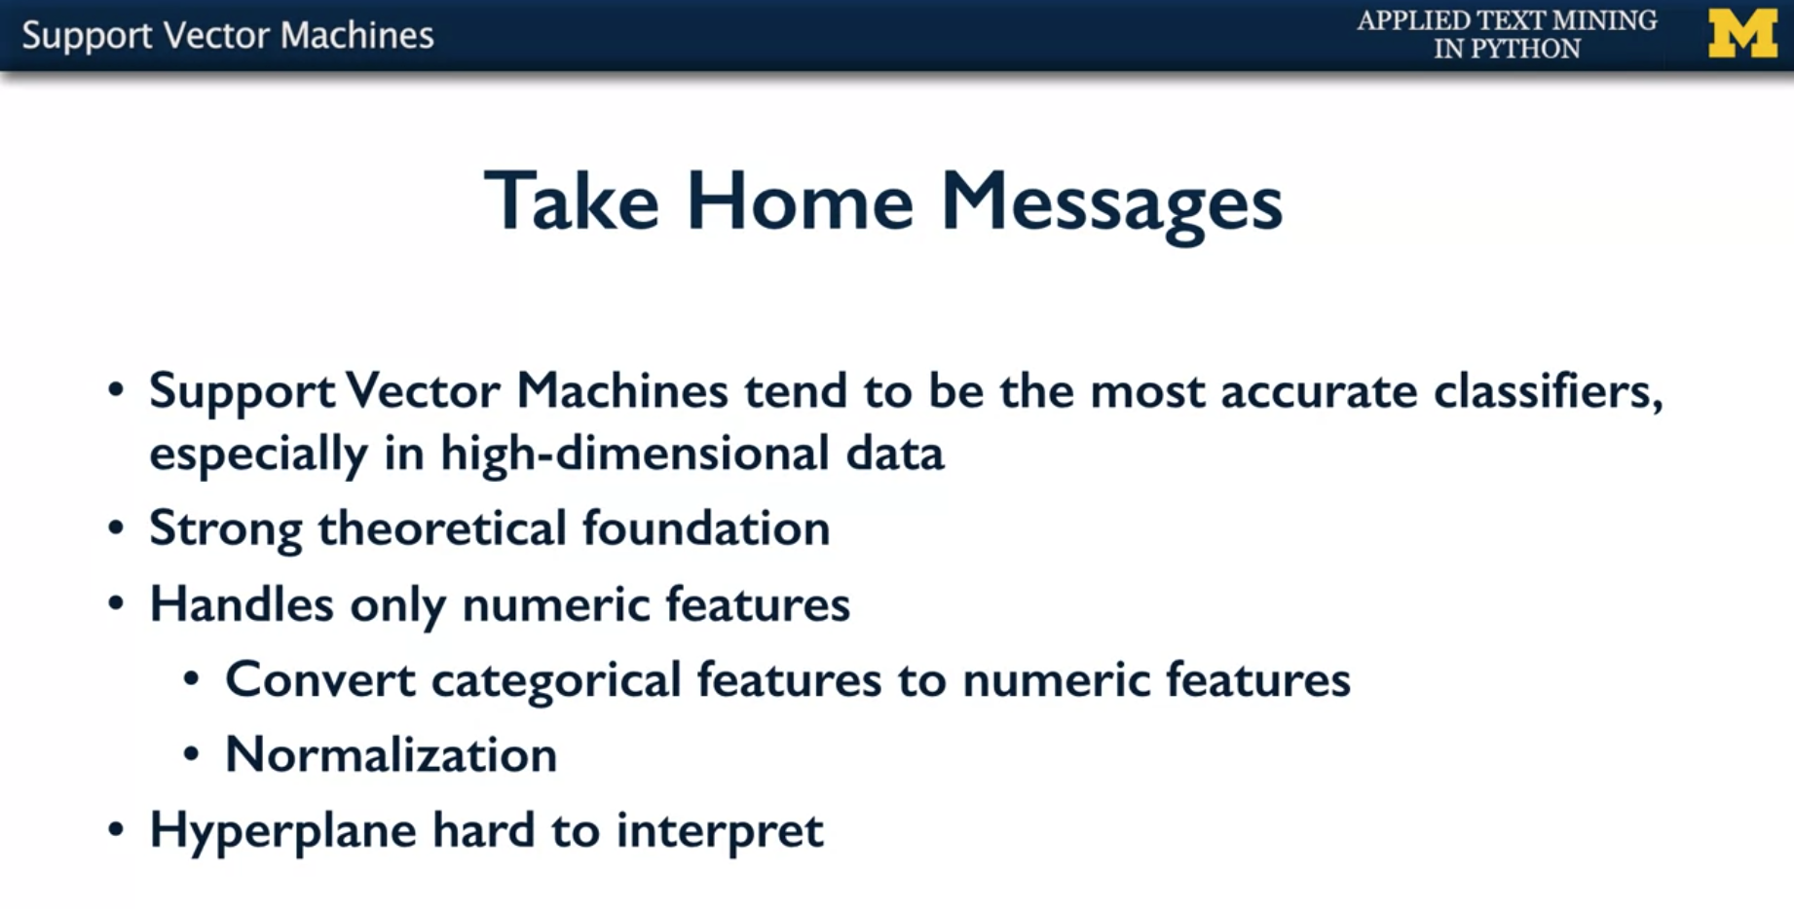

* But to conclude, the big take home messages from support vector the machines is that, these tend to be most accurate classifieds for text, especially when we are talking about high-dimensional data, as text data typically is.
* There are strong theoretical foundations for support vector machines. It's based out of optimization theory
* Support vector machine handles only numeric data. So what would you do with other data? You typically can word these categorical features into numeric features. As you can see this is a dot product based algorithm. So it uses numbers to define whether it should be boundary on one side or the other. So it works only on numeric features.
* You would also want to normalize the features. That means you don't want some dimensions to be very high in numbers, and other dimensions to be very low. You would want to put them all in a zero to one range, so that each feature gets enough importance and you can learn the relative importance that way.
* But in general, the hyperplane that you learn even that they're very easy to learn and easy to test, they are hard to interpret. Which means that you don't really know why a particular point has been labelled as positive or negative.
* It's a combination of multiple factors. But in general if explanation is not a critical requirement for the classifier, support vector machines do give you very high and very accurate classifiers, very similar to naive bayes. In fact for a lot of text classification problems, support vector machines should be one of the first ones you should try.

